

Restaurant Point of Sale

Rest POS

**MySQL** Database server configuration guide

March 28, 2018

DynamicSoft

http://www.codecanyon.net/user/dynamicsoft

**How to setup MySQL Database script into MySQL Server/phpmyadmin**

Before doing operation please read every single word at least ten then move to forward

Video tutorial -> [**How to use Rest POS with MySQL**](https://www.youtube.com/watch?v=2ceGGKsGbRs)

Requirement _____________________________________________________________

* **Visual studio 2013 – up-to** target Framework="4.5"
* **MySQL server** Server version: 10.1.13-MariaDB, phpMyAdmin 4.5.1

**Step**: 1

How to Setup MySQL Database __ > [**Youtube**](https://www.youtube.com/watch?v=jW5lrS6EUPM) , [**YTD2**](https://www.youtube.com/watch?v=x-R7VnUSXyc)

1. Open Your MySQL server with Xampp [phpmyadmin](http://localhost/phpmyadmin) or workbench tools. http://localhost/phpmyadmin
2. Create a New Database in your phpmyadmin DB Name is = “**restpos**”

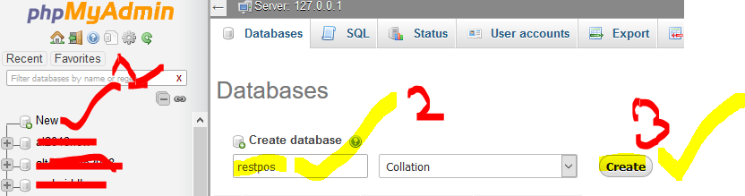

**Import Sample Video - How to setup APOS using MySQL DB – Check this Official video**   
<https://www.youtube.com/watch?v=g91NRvQBRms&t=1673s>

## How to Import database script

Select Database 🡪 **restpos** and click ***Import*** tab  
Follow on youtube How to DB import 🡪 <https://www.youtube.com/watch?v=jW5lrS6EUPM>

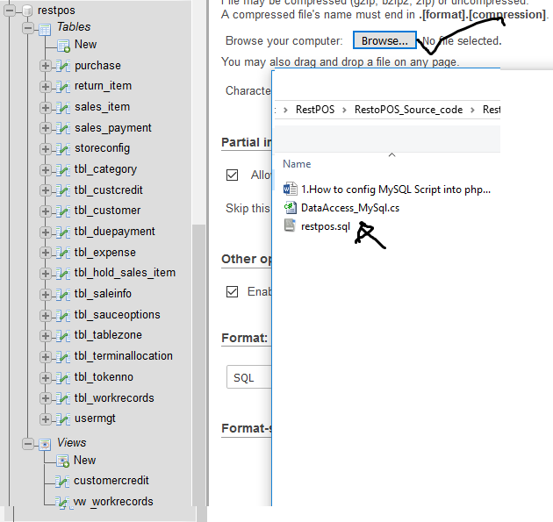

And Upload from Restpos_MySql folder -> **restpos.sql** fileand press **Go**

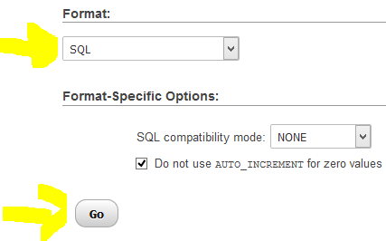

Now see your all tables and views **restpos** done

***** **Install** [**mysql-connector-net**](http://ftp.ntu.edu.tw/MySQL/Downloads/Connector-Net/mysql-connector-net-6.9.9.msi)  **(If Not installed)**

**Add Reference MySql.Data.dll file (if not in VS project)**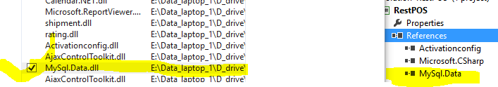

[Open the project](https://www.youtube.com/watch?v=AcOoGkG0m8I) with Visual studio 2013. Just click on 🡪 ***RestPOS.sln*** file

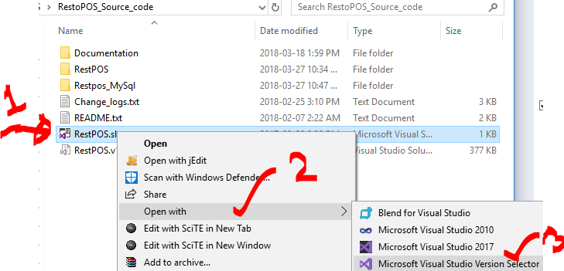

🡪 Delete Current DataAccess_SQLiteEdition.cs file from solution explorer   
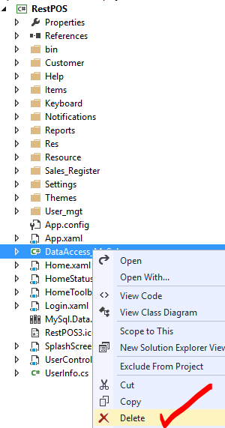

1. And Copy " **DataAccess_MySql.cs** " file from [Restpos_MySql] folder then paste into solution explorer -> **RestPOS** project  
   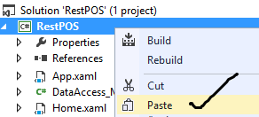

Open "DataAccess_MySql.cs” file and change your DB source, Database name, User ID, Password.

//This is MySQL Database Access

static string _ConnectionString = "server=localhost; database=**restpos**; uid=root; PASSWORD=1234 ";

   // server = your server name like IP address 127.0.0.1 or domain name  
//database = your database name   
//uid = MySQL user id

Or

static string _ConnectionString = "server=localhost; database=restpos “;

 // Password = MySQL or cpanel database user ID (default is empty)

3. Build and Run or press F5 (**Before run, please Enable MySQL Query and Disable Sqlite query – See next page**)

How to switch **MySQL server** to --> SQLite **server**

1. Delete Current **DataAccess_MySql.cs** file from solution explorer
2. and Copy "**DataAccess_SQLiteEdition.cs**" file then paste into solution explorer **RestPOS** project
3. Build and Run

Video -> <https://www.youtube.com/watch?v=2ceGGKsGbRs&t=741s>

## Enable MySQL Query

Enable below code and comment SQLite Query from Below 7 pages  


**User_list.xaml.cs**

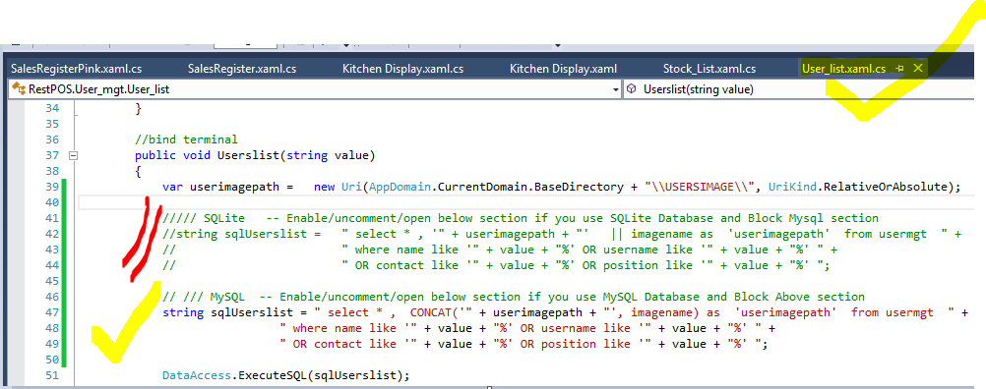

**Stock_List.xaml.cs**

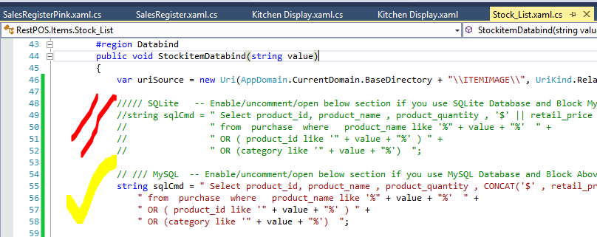

**Kitchen_Display.xaml.cs**

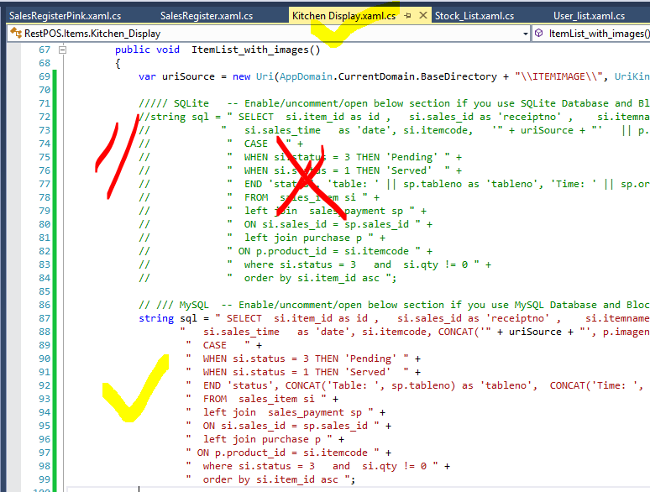

**SalesRegister.xaml.cs**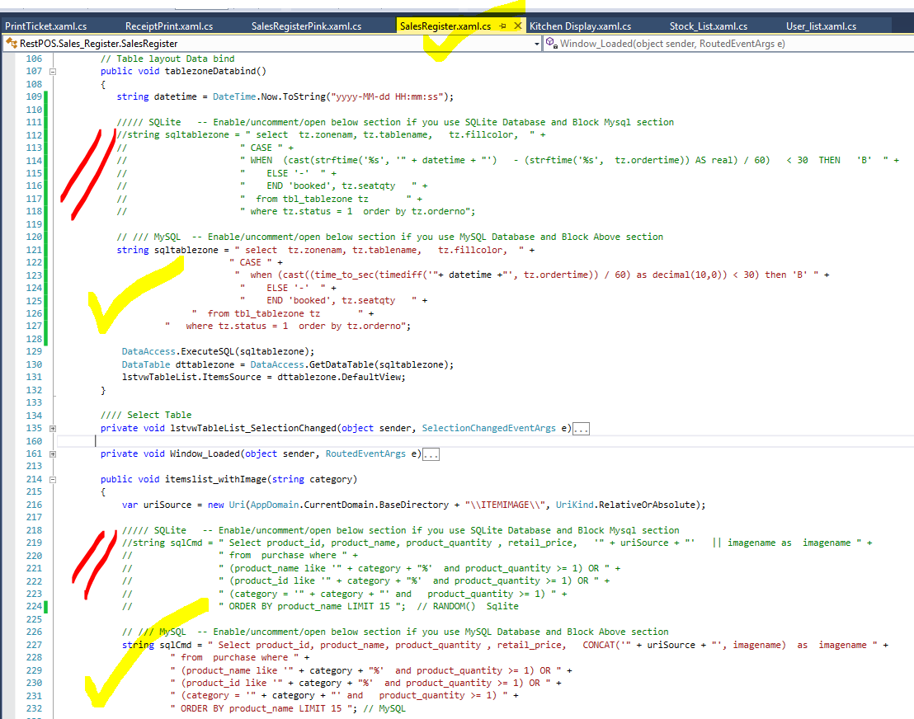

**SalesRegisterPink.xaml.cs**

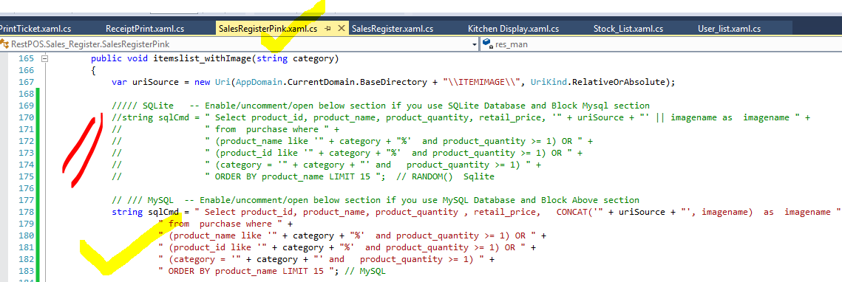

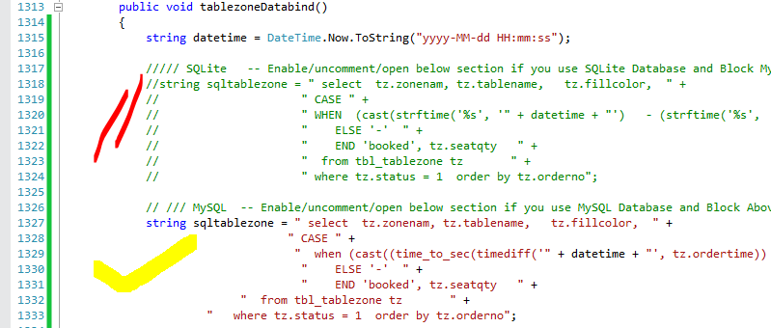

**ReceiptPrint.xaml.cs**

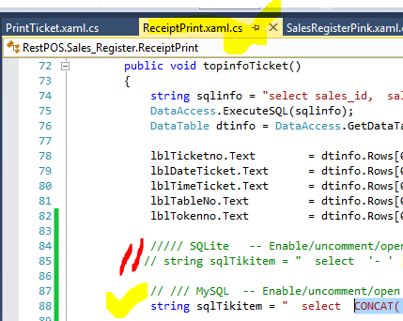

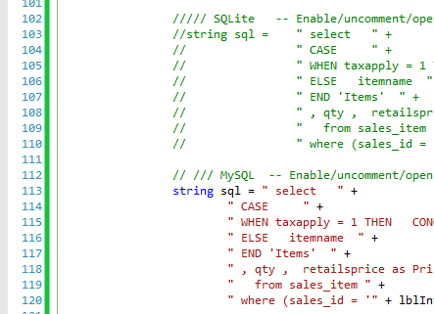

**PrintTicket.xaml.cs**

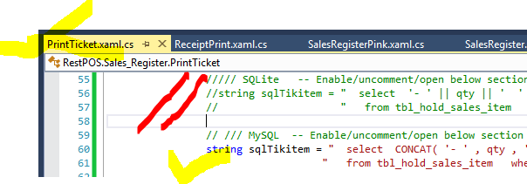

Optional Setup  
**How to Automatically Open Your Cash Drawer**

<https://www.youtube.com/watch?v=ECid5KGzuzw>

**How to make installer from source code**

Step 1: Please create a new project. (Do not create installer file/project in same project.)

Our Official Video tutorial

<https://www.youtube.com/watch?v=4ca8HPnY8hE>

Please don’t forget to Rate us <http://codecanyon.net/downloads>



[DynamicSoft](http://www.codecanyon.net/user/dynamicsoft)